- Network Topologies Theory

Q1. Draw a diagram of a bus topology and label all key components, then write one real-world example where this topology might be used?

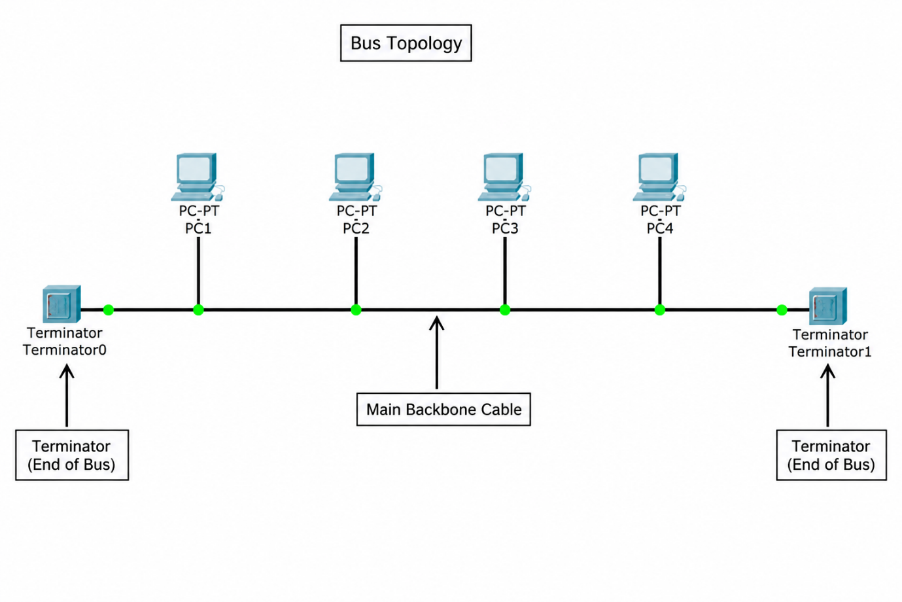
Answer

- Bus Topology – Real-World Example
In a bus topology, all devices are connected to one main backbone cable. Terminators are placed at both ends of the cable to prevent signal reflection.
- Real-world example: A bus topology can be used in a very small or temporary network where low cost and less cabling are important.

Q2 . In Cisco Packet Tracer, create a simple star topology with one switch and four PCs connected to it; name each PC after a popular app (e.g., WhatsApp, Zomato, Spotify, Flipkart) and take a screenshot of your topology?

Answer

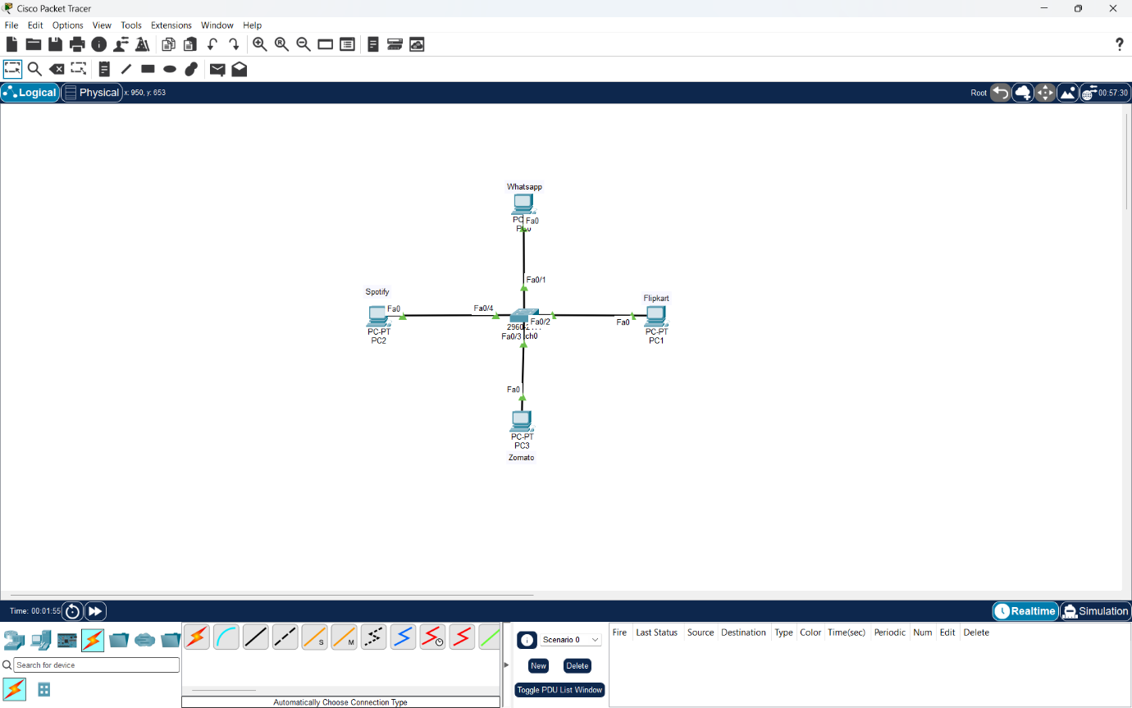
- Star Topology in Cisco Packet Tracer
I created a star topology in Cisco Packet Tracer using one Cisco 2960 switch and four PCs. The PCs were named WhatsApp, Zomato, Spotify, and Flipkart. All four PCs were connected to the central switch using Ethernet cables.
- Result:
The star topology was created successfully.

Q3. Draw a ring topology diagram and explain in 2-3 sentences how data travels between devices in this setup.<br><br><em><strong>Hint:</strong> Use arrows to show the direction of data flow.</em>?

Answer

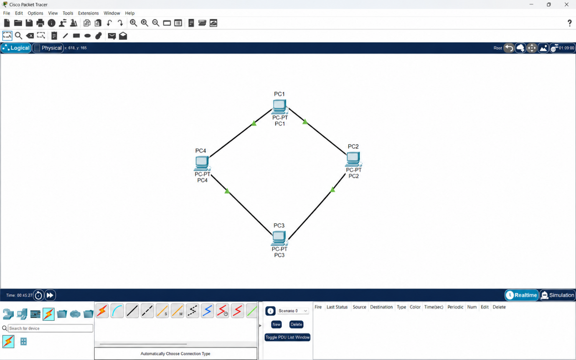
- Ring Topology
In a ring topology, each device is connected to two neighboring devices, forming a closed loop. Data travels from one device to the next in the direction shown by the arrows until it reaches the destination.
- Result:
The ring structure provides an organized path for data transmission between all connected devices.

Q4. Compare mesh and star topologies by listing 2 advantages and 2 disadvantages of each in a table format?

Answer

- Mesh vs Star Topology
Topology | Advantages | Disadvantages
- Star | 1. Easy to install and troubleshoot  2. Failure of one device or cable does not affect the others | 1. If the central switch fails, the whole network can be affected  2. Requires more cabling than some other topologies
- Mesh | 1. Very reliable because multiple paths are available 2. If one link fails, data can use another path | 1. Expensive because many connections are required  2. Complex to install and manage

- Conclusion:
Star topology is simpler and more cost-effective for normal office or home networks, while mesh topology is better when high reliability and backup paths are important.

